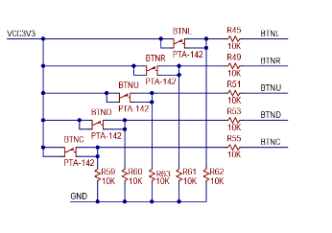

clock period 1/100*10^6 = 10 ns

number of periods 2*10^-3/10*10^-9=200000

| **ime interval** | **Number of clk periods** | **Number of clk periods in hex** | **Number of clk periods in binary** |
| --- | --- | --- | --- |
| 2 ms | 200 000 | x"3_0d40" | b"0011_0000_1101_0100_0000" |
| 4 ms | 400000 | x“6_1a80“ | b“0110_0001_1010_1000_0000“ |
| 10 ms | 1000000 | x“f_4240“ | b“1111_0100_0010_0100_0000“ |
| 250 ms | 25000000 | x“17d_7840“ | b"1_0111_1101_0111_1000_0100_0000" |
| 500 ms | 50000000 | x“2fa_f080“ | b"10_1111_1010_1111_0000_1000_0000" |
| 1 sec | 100 000 000 | x"5F5_E100" | b"0101_1111_0101_1110_0001_0000_0000" |